Tracewise AI
AI Across the Product Development Lifecycle
Hackathon 2026 | Intelligent Requirement-to-Test Traceability

1. Problem Definition
Manual requirement-to-test traceability is slow (4+ hours per analysis), error-prone, and breaks when documents are scattered across formats. Coverage gaps go undetected until production failures. Our solution automates the entire requirement-to-test lifecycle in 30 seconds.
- Multi-format upload: PDF, DOCX, Markdown, Text parsed automatically
- 6 domain samples demonstrate real-world breadth (Software, EV, Civil, Mechanical, Payments, Aerospace)
- Backwards compatibility handles test cases written before requirements exist

2. Solution Architecture
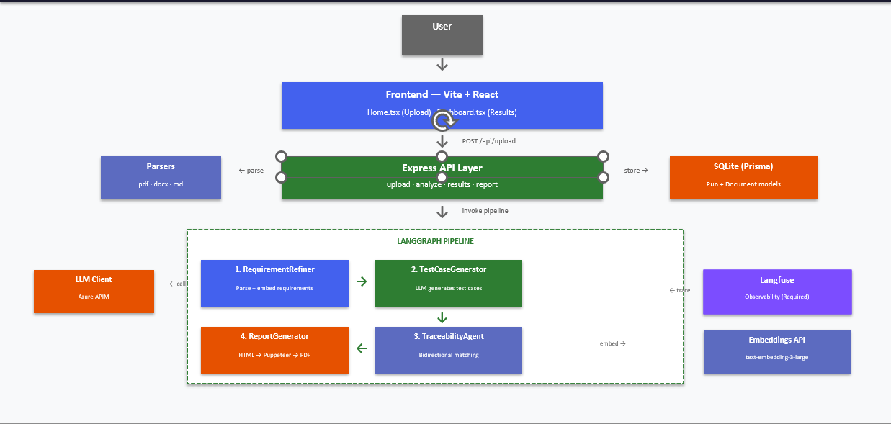
4-node LangGraph state machine: Requirement Refiner → Test Case Generator → Traceability Agent → Report Generator. Each node has independent fallback logic — no single point of failure. Express REST API with Prisma/SQLite persistence, Vite React frontend, Langfuse observability.
- LangGraph StateGraph with typed annotation (graph.ts)
- Shared AgentState interface across all agents (state.ts)
- RESTful API: upload, analyze, results, report (routes/)
- Bidirectional pipeline: forward (requirement→test) + reverse (orphan detection)

3. Engineering/Build Quality
TypeScript strict mode throughout. Clean separation: agents/, routes/, parsers/. Every AI component has a non-AI fallback. Monorepo with npm workspaces. Professional CSS design system with custom properties and responsive breakpoints.
- TypeScript strict mode enabled in tsconfig.json
- Fallback chain: LLM → regex, embeddings → word-level, Puppeteer → HTML
- Modern momolithic workspaces: backend + frontend

4. AI Appropriateness
AI is used where it genuinely adds value — not everywhere. LLM handles unstructured→structured extraction and test case generation. text-embedding-3-large generates semantic vectors for matching. Traditional code handles file parsing, report rendering, and database operations.
- LLM called only in 2 of 10 source files (requirement-refiner.ts, test-case-generator.ts)
- text-embedding-3-large via Azure APIM generates 1536-dimension vectors for semantic matching
- File parsing uses pdf-parse/mammoth (no AI needed)
- Report generation is HTML→PDF (no AI needed)

5. AI Implementation
Structured prompt engineering with JSON output format. text-embedding-3-large generates 1536-dimension vectors, matched via cosine similarity (threshold 0.6) with word-level Jaccard fallback (threshold 0.2). Bidirectional traceability: forward matching + orphan detection. Langfuse traces every LLM and embedding call.
- 4-level test generation prompt (Unit/Integration/System/Acceptance)
- text-embedding-3-large vectors → cosine similarity for requirement-test matching
- Orphan detection via reverse traceability pass
- Langfuse observability with trace/span logging on every LLM and embedding call

6. AI Impact
Converts 4+ hours of manual traceability into 30 seconds. Bidirectional coverage analysis catches gaps humans miss. Multi-format compliance output (PDF/TXT/DOCX) for regulated industries. Graceful degradation ensures the system never blocks the user.
- Semantic match: Google Login vs Verify OAuth sign-in → 85% similarity (keyword: 15%)
- 5 domain samples with ~42% coverage analysis completed in seconds
- Orphan detection finds test cases with no linked requirement (3 orphans in backwards-compat sample)
- Compliance documents generated in PDF, TXT, DOCX formats

7. Business Relevance
PDLC traceability is a real pain point in regulated industries (automotive, banking, civil etc). Multi-domain support means one product serves many verticals. Compliance document generation is exactly what auditors require.
- 5 industry-specific sample datasets with domain-appropriate requirements
- Multi-format output (PDF/TXT/DOCX) for compliance delivery
- Backwards compatibility addresses real-world scenario: tests before specs finalized
- Cross-domain architecture reasoning documented in jury Q&A notes

8. Benefits & Viability
Zero-dependency deployment: SQLite + local LLM calls. Works offline with regex fallback. Domain-agnostic architecture — swap the template, not the code. Graceful degradation at every layer ensures the system is always usable.
- SQLite — no database server needed, zero-install
- LLM unavailable → regex parsing fallback (requirement-refiner.ts)
- Embeddings API fails → word-level similarity fallback (test-case-generator.ts)
- Puppeteer fails → HTML report fallback (report-generator.ts)

9. Working Demo
Full end-to-end flow: upload → analyze → dashboard → PDF report. Visual dashboard with traceability matrix, coverage gaps, orphan detection, and type-filtered AI-generated test cases. 6 domain samples ready to test.
- Drag-and-drop upload with file validation (Home.tsx)
- Dashboard: 5 summary cards, traceability matrix, gap analysis, orphan section, type filter
- 6 domain subfolders + backwards-compat with test data
- Generated PDF reports from live analysis runs

10. Differentiation
Bidirectional traceability (orphan detection) is uncommon — most tools only do forward mapping. Domain-agnostic engine with 5 industry samples. Backwards compatibility handles real-world incomplete data. Multi-format compliance output for regulated industries.
- Reverse traceability pass detects test cases with no matching requirement
- 6 domain subfolders: software, EV, civil, mechanical, payments, aerospace
- backwards-compat sample: 3 orphan test cases detected automatically
- Multi-format compliance output (PDF/TXT/DOCX) from markdown source

